EX:5A | DATA VISUALIZATION USING MATPLOTLIB  (CREATING A DATASET)
DATE: | DATA VISUALIZATION USING MATPLOTLIB  (CREATING A DATASET)

AIM:
To create and analyze various data visualizations such as Line Charts, Bar Charts, Pie Charts, Histograms, Scatter Plots, and Box Plots using Matplotlib for effective data interpretation.

ALGORITHM
- Start.
- Import the required libraries, Pandas and Matplotlib.
- Create a Breast Cancer dataset using Python lists and construct a DataFrame.
- Display the created dataset.
- Create a Line Chart to show the variation in tumor radius.
- Create a Bar Chart to compare the average radius of benign and malignant cases.
- Create a Pie Chart to show the distribution of benign and malignant cases.
- Create a Histogram to display the distribution of tumor radius.
- Create a Scatter Plot to show the relationship between tumor radius and area.
- Create a Box Plot to identify the distribution and possible outliers in tumor area.
- Create a Multiple Line Chart to compare radius and texture.
- Add suitable titles, labels, and legends to the charts.
- Display and interpret the visualizations.
- Stop.

PROGRAM AND OUTPUT:

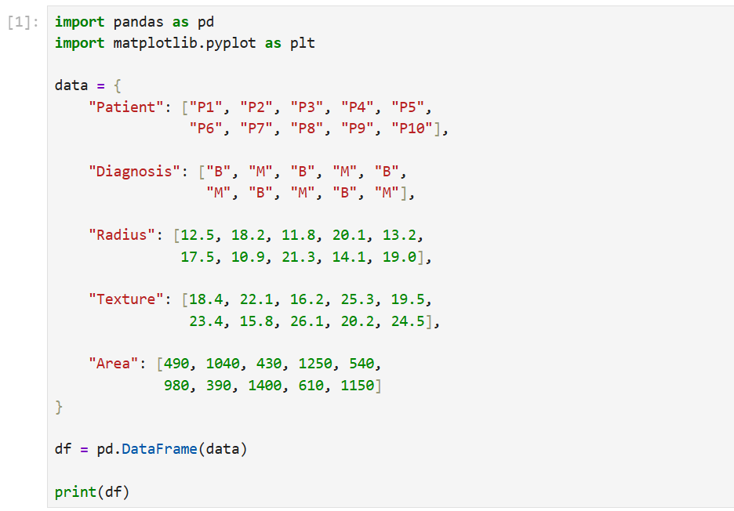
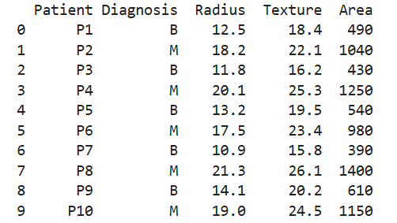
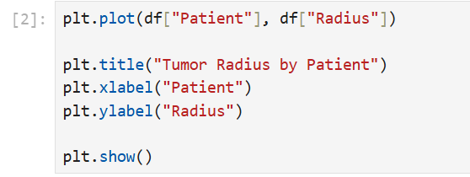
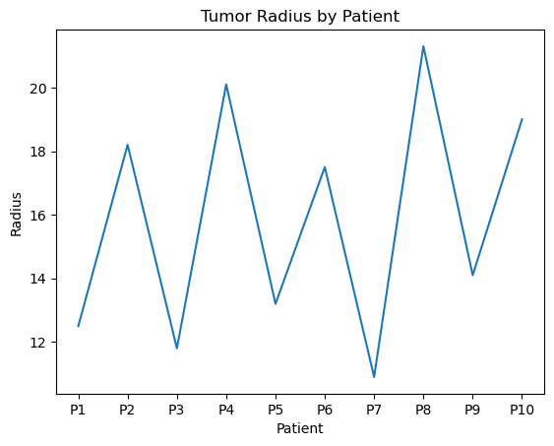
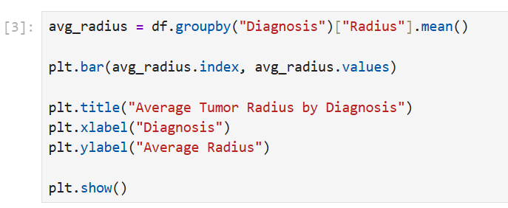
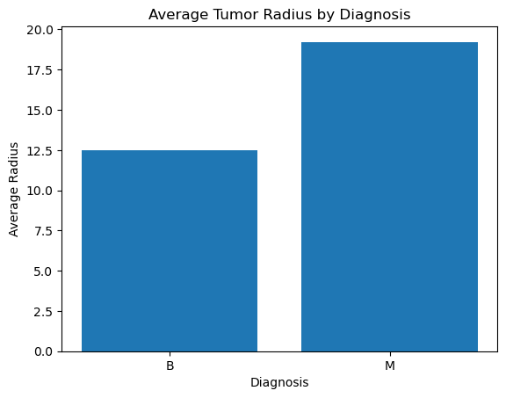

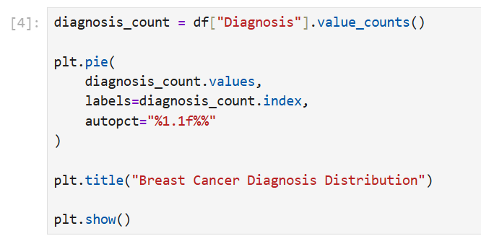

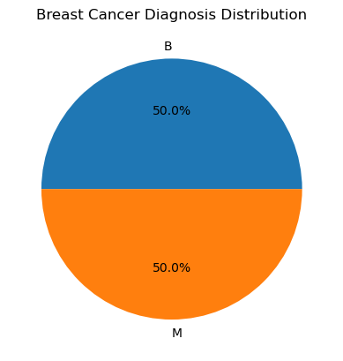

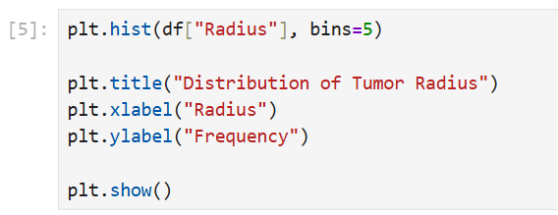

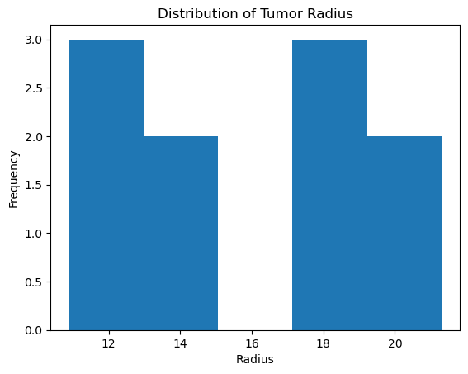

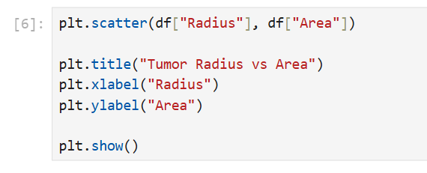

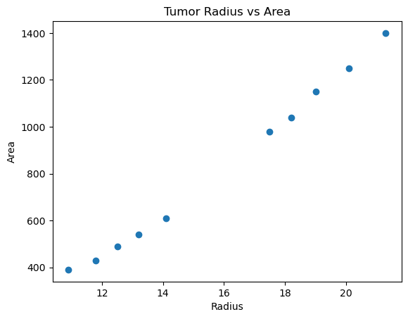

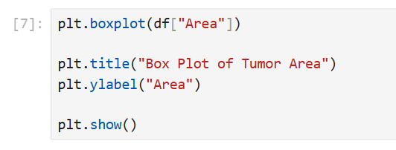
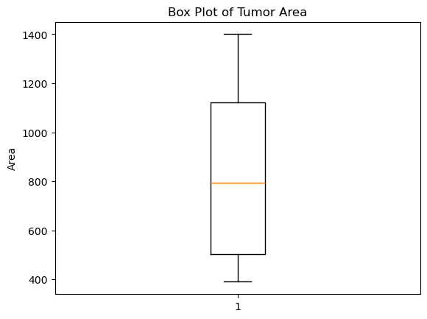

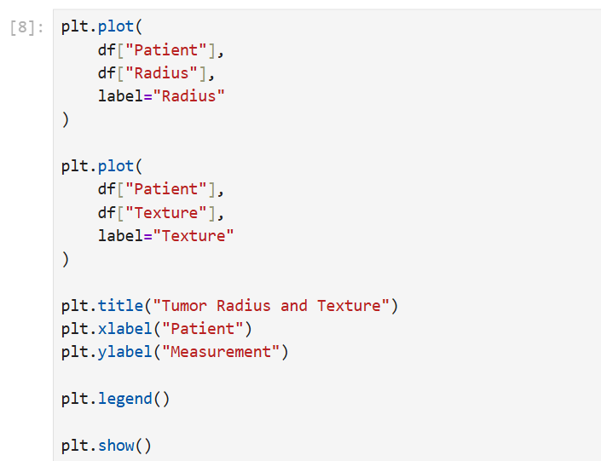

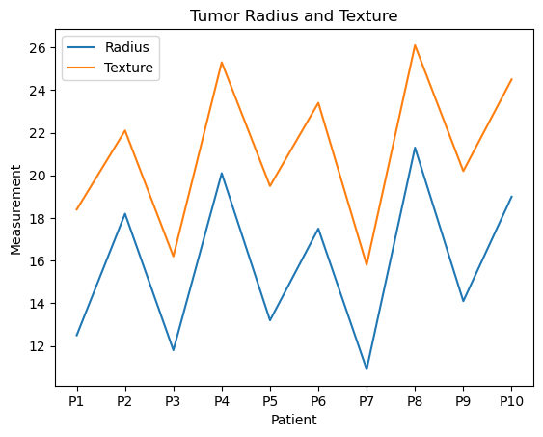

RESULT:
Thus, the Breast Cancer dataset was successfully created in Jupyter Notebook, and various visualization techniques including Line Chart, Bar Chart, Pie Chart, Histogram, Scatter Plot, Box Plot, and Multiple Line Chart were successfully implemented using Matplotlib. The visualizations helped in understanding tumor measurements, diagnosis distribution, data frequency, relationships, and variations in the dataset.

